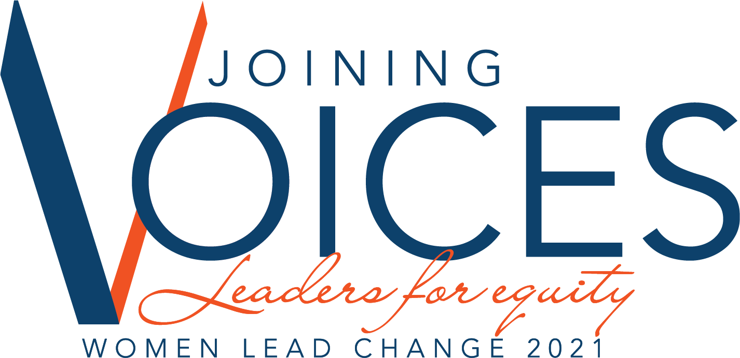
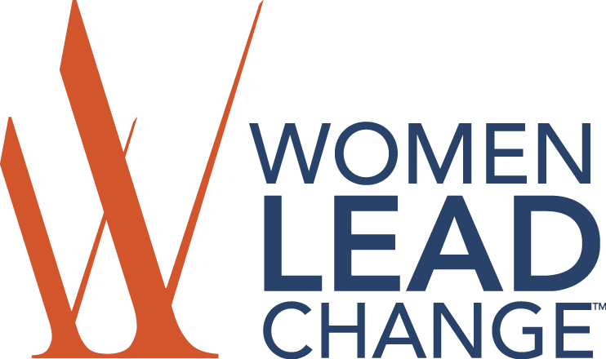

2021 SCHOLARSHIP OVERVIEW & DIRECTIONS ______________________________________________________________________

PURPOSE: To provide registration scholarships to individuals to further enhance their leadership skills by attending a Women Lead Change sponsored event.

WHO QUALIFIES: A limited number of scholarships are available for small business owners and employees, non-profit staff, unemployed, and/or those experiencing financial need. Individuals are eligible for a one-time Conference Scholarship Award, unless transitioning from the Student Track program.

SCHOLARSHIP AWARDS: Awards will be applied to cover the FULL amount of Conference registration fee. Scholarships are not awarded as cash and DO NOT include travel expenses.

SCHOLARSHIP SELECTION COMMITTEE: There is a separate Scholarship Selection Committee for each WLC region: ICR (Iowa City/Cedar Rapids); Central Iowa (Des Moines); and Quad Cities. All decisions of the committee shall be final.

DIRECTIONS & HOW TO APPLY: Applicants must submit the official Women Lead Change Scholarship Application Form and required narratives to Women Lead Change by email to morgan.schmall@wlcglobal.org (ICR), bobbi.segura@wlcglobal.org (CENTRAL IOWA) or morgan.schmall@wlcglobal.org (QUAD CITIES).

1. Download the official Scholarship Application Form.
2. Complete all sections. Incomplete applications will not be considered.
3. Email completed application to morgan.schmall@wlcglobal.org (ICR), bobbi.segura@wlcglobal.org (CENTRAL IOWA) or morgan.schmall@wlcglobal.org (QUAD CITIES).
4. You will receive a confirmation email of receipt confirming receipt of application only. Scholarship award decisions will be communicated after review by the Scholarship Selection Committee.

DEADLINES: The Scholarship Application form is due:
- ICR Iowa: March 30, 2021
- Quad Cities: Sept. 5, 2021
- Central Iowa: Sept. 15, 2021

FOR MORE INFORMATION please email info@wlcglobal.org
______________________________________________________________________

Please check the box for which conference you are applying for:
⃞ ICR Iowa Conference, May 4, 2021
⃞ Quad Cities Conference, Oct. 13, 2021
⃞ Central Iowa Conference, Oct. 27-28, 2021

Please check the box for which scholarship you are applying for:
⃞ Professional Track
To be granted to individuals, companies or non-profits seeking registration assistance.
⃞ Joining Voices
To be granted to individuals from non-profit organizations whose mission is to serve and provide advocacy for minority communities.

PART ONE: GENERAL INFORMATION, EXPECTATIONS & REQUIREMENTS

NAME
ADDRESS
PHONE
EMAIL
EMPLOYER NAME, CITY & STATE

Why are you interested in attending the 2021 WOMEN LEAD CHANGE CONFERENCE? Check all that apply.
Personal Growth
Career Growth
Leadership Tips
Networking

SCHOLARSHIP RECIPIENT EXPECTATIONS & REQUIREMENTS:
1. Attend all program sessions during the event. If, for some reason you are not able to attend, please contact Women Lead Change.
2. A Scholarship Testimonial Form will be sent to you within a week of the conference. Within fifteen (15) days of receipt of this form, complete and return to the email listed on that form.

I agree to abide by these expectations and requirements:

SIGNATURE: DATE:

PART TWO: REQUIRED NARRATIVES

Please provide a 1-2 paragraph response for each of the following topics:

1. Why do you want to attend the 2021 WOMEN LEAD CHANGE CONFERENCE? Why should you be chosen to receive a scholarship? (15%)

2. Please describe your leadership style. (15%)

a. Who has most influenced your leadership style?

b. How has that person helped you develop as a leader?

3. Describe your financial need for the scholarship. Will you attend the 2021 WOMEN LEAD CHANGE CONFERENCE if you do not receive a scholarship? (30%)

4. Describe what diversity and inclusion means to you. (25%)

a. What do you do to support diversity and inclusion, personally and professionally?

5. List your volunteer involvement and extracurricular activities. (15%)

Organization Name | Describe Activity/  Your Volunteer Role | Dates Involved | Frequency of Volunteering

PART THREE: MISCELLANEOUS INFORMATION

We need your help! Women Lead Change strives to be as inclusive as possible in serving women and their leadership development needs. As we grow and approach organizations for funding, we are asked about the audiences we serve on a representational basis, not individually. This information is NOT used in the selection process and we will NOT use or share this information for any other purpose!

CLASSIFICATIONS
Which of the following best represents your racial/ethnic heritage?
(Choose all that apply)
⃞ Hispanic or Latino (A person of Cuban, Mexican, Puerto Rican, South or Central American, or other Spanish culture or origin, regardless of race.)
⃞ American Indian or Alaska Native
⃞ Asian
⃞ Black or African American
⃞ Native Hawaiian or Other Pacific Islander
⃞ White
⃞ Do not wish to disclose

Do you identify as LGBTQIA+? ⃞ yes ⃞ no ⃞ do not wish to identify

